Project Design Phase-II

# Data Flow Diagram& User Stories

|  |  |
| --- | --- |
| Date | 09 NOV 2022 |
| Team ID | PNT2022TMID34757 |
| Project Name | Smart waste Management System in Metropolitan Cities |
| Maximum Marks | 4 Marks |

# Data Flow Diagrams:

A Data Flow Diagram (DFD) is a traditional visual representation of the information flows within a system. A neat and clear DFD can depict the right amount of the system requirement graphically. It shows how data enter and leaves the system, what changes the information, and where data is stored.

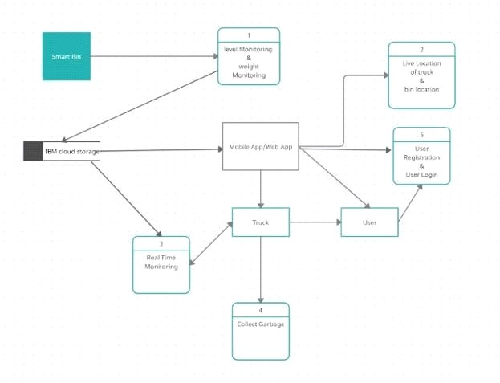

# User Stories

Use the below template to list all the user stories for the product.

|  |  |  |  |  |  |  |
| --- | --- | --- | --- | --- | --- | --- |
| **User Type** | **Functional Requirement**  **(Epic)** | **User Story**  **Number** | **User Story / Task** | **Acceptance criteria** | **Priority** | **Release** |
| Primary admin | login | USN-1 | As a primary admin , I can  manage the webserver | I can access  account / dashboard | Medium | Sprint-2 |
| Secondary admin | login | USN-2 | As a secondary admin, I can  Monitor the | I can access the location | High | Sprint-1 |

|  |  |  |  |  |  |  |
| --- | --- | --- | --- | --- | --- | --- |
|  |  |  | trucks |  |  |  |
| Truck driver | dashboard | USN-3 | As a truck driver, I reach to the correct destination to collect  the garbage. | I can register & access the location via dashboard | Medium | Sprint-2 |
| Local garbage collector | dashboard | USN-4 | As a local garbage collector, I collect the  garbage from the bins | I can register & access the location | Medium | Sprint-2 |